Creating and Troubleshooting Flows

Table of Contents
Creating and Troubleshooting Flows 1
1 Introduction 2
2 Coordinates and Movement 2
3 Timing and Frames 3
4 High Level Flow Execution Process 4
5 Movement Breakdown 5
6 Creating Basic Flow Commands 5
6.1 Initial NEW_FLOW 5
6.2 FLOW Commands 6
6.3 Long Form FLOW Command – Leg Movement 6
6.4 Short Form FLOW Command – Cycles & Toe Safety 7
6.5 Final DO_FLOW Command 7
7 Putting Flow Commands into a Script 8
8 Prepare for Testing 9
9 Do Test Run 10
10 Check for Toe Safety Box Violations 10
11 Graph the Toe Movement 11
12 Run the Script with Movement Enabled 12
13 Troubleshoot Unexpected Behaviours 13
14 Document the Script 13
15 Reference Information 13
15.1 Global Coordinates of Key Locations 13
15.2 Local Coordinates for Home Position (same for all legs) 14
15.3 Operations Field in FLOW Commands 14
15.4 Toe-Action Coding in Final DO_FLOW Command 14
16 Example FLOW Commands 15
16.1 Move leg 1 to its home position 16
16.2 Move leg 1 to a position 4 Cm in front of its home position 18
17 Example Flow Script -Taking A Step 20
17.1 The Sequence of Actions 21
17.2 Converting Actions to Flow Commands 22
17.3 Consolidated Flow Listing 23

Introduction
Flows are text files that control movement of the legs on the Hexbot robot, and thus the movement of the robot itself. They are written in the javascript-like scripting language of the MQTT.fx utility that communicates with the robot using the MQTT protocol over Wifi.

The goal is to give minimum information to have Hexbot move toes on 6 legs in parallel from one position to the next, repeatedly in an overall sequence.

Flows can be created by hand, using a simple text editor like Notepad++ to enter them. Since 18 numbers are needed to specify toe movements, this is somewhat tedious. In some cases, it’s helpful to use a spreadsheet to create some of the numeric coordinates, export it to CSV format, and then transplant the calculated numbers into a flow.

Flow files have the .js file extension. Email programs typically don’t allow attachments with the .js extension, so if they’re renamed to .txt files temporarily for emailing purposes.

All coordinates and distances in this document are expressed in centimeters, and 2 decimal places of accuracy is sufficient, considering the resolution of our servos..

A project is under way to create a compiler that will allow creation of flow files using high level commands. This will be simpler, less labour intensive and more reliable. The troubleshooting section of this document may still be useful when the robot’s behaviour doesn’t match expectations.

Coordinates and Movement
As implied by the name, the Hexbot has 6 legs, each of which contains 3 servo motors. The hip servo is mounted on the chassis. The knee servo is the next one outward, and the ankle is the last one. The link from the hip to the knee is called the thigh, and from the knee to the ankle is called the shin. The endpoint of the leg is called the toe, and the link between it and the ankle servo is called the foot.

Moving the robot is done in steps, each of which includes moving each leg at the same time to a new position. There are two main ways of specifying a toe position: global coordinates, and local coordinates.

Global coordinates are relative to the chassis of the robot. The +X direction is towards the front, the +Y direction is towards the robot’s left side, and the +Z direction is upwards. The global origin is at the geometric center of the chassis, at the same height as the rotation center of the middle servo (“knee”).

Local coordinates are relative to each leg, and all 6 legs are oriented differently. The local coordinate system is about to undergo a naming change, but for now, these axis names apply. The +X direction is straight out from the hip servo, the +Y direction is upwards, and the +Z direction is perpendicular to both X and Y axes, with positive being to the left when looking in the +X direction. Note that because of the way the servos are mounted, the +Z direction points towards the front on the Hexbot’s the right side, but towards the back on the left side.

To specify a step that is part of leg movement, you need to specify the new location for each of the 6 toes. These each need 3 coordinates, so this requires 18 numbers. There are several ways to give these coordinates, and you can use which ever one is convenient:
- absolute coordinates for each toe
- local coordinates for each toe.

You can also give positions as an offset from the home, or neutral position. The home position occurs when all the servos are at their center position. The local coordinates for the home position are (13.78, -10.60, 0) for all 6 legs. You can specify offsets from the home position as follows:
- offsets from the global coordinates of the home position, using global coordinate offsets. In this case, the 3 numbers refer to the global X,Y and Z directions
- offsets from the local coordinates of the home position, using local coordinate offsets. In this case, the 3 numbers refer to the local X, Y and Z directions

Planned, but not yet implemented, is another specification method, which is relative to the previous position of the toe, using either global or local coordinate offsets.

Timing and Frames
It might seem that the process of moving one leg’s toe to its position in the next flow would require just 3 servo movements, one for each servo in the leg. However, it’s a bit more complicated. There are a number of intermediary points that the servos move to, for 2 reasons:
- We want to control the speed of the movement
- We want the path of the toe to be a good approximation of a straight line.
These intermediary locations are referred to as frames. The number of frames for a movement varies, and is determined by 2 things:
- The amount of time allowed for each frame movement. This is equivalent to the the desired frame rate, such as 24 frames per second. The default value for the frame time, f_msecPerFrame, is 50 milleseconds, which can be overridden in the DO_FLOW command of a script.
DO_FLOW, toeMoveAction, 50
This corresponds to a frequency of 20 frames per second, which has proven to be a practical value.
- The total time specified in the FLOW command for the toe movement. This is the first number in the FLOW command, and it’s expressed in milliseconds. A movement taking one second would have the value 1000 for this field.
FL, 1000, 3, 10, 0, 0, 0, 0,0,0, 0,0,0, 0,0,0, 0,0,0, 0,0,0, 0,0,0
The number of frames for a movement (f_framesPerPosn) is the total time for the movement, divided by the time specified for each frame. In the examples above, the number of frames would be 1000 / 50 = 20, because that is the number that will fit into the allotted time.
The debug features that display and graph information for each toe position work on a frame by frame basis. This is why a particular flow row number will appear multiple times is these displays – you’re seeing data for each frame, and there are usually multiple frames for the movement described by one FLOW command.

High Level Flow Execution Process
The steps to create movement of the robot are below. Each of these will be expanded in the following sections.
- Break the desired robot movement down into sections, and make a rough plan for each section.
- Create flow commands to implement each section. (Due to use of open loop servo motors that don’t provide feedback on current position, we start in the dark, not knowing where the toes are.)
- Wrap the MQTT.fx script syntax around your flow commands. This is easily done by modifying a previously working script to use your flow commands, and other parameters.
- Prepare for testing without actually moving the servos by adjusting the final DO_FLOW command’s first parameter, which can also be used to enable some debugging outputs. You can also disable leg movement by turning off the 5 volt power to the PWM boards.
- Use the MQTT.fx script command to load the flow into the Hexbot and execute it.
- Check for toe safety violations on the console, which will halt execution of the script.
- Optionally create a graph of the toe movements, and verify they’re what you expect.
- Enable actual leg movement by adjusting the DO_FLOW toeMoveAction parameter and/or turning on 5 volt power to the PWM boards. Reload, and execute the flow.
- Troubleshoot any unexpected behaviours
- Document the script

Movement Breakdown
Dividing a script into smaller pieces simplifies the creation effort, and debugging. When the movement consists of a gait with 2 phases, it makes sense to do each phase as a section. As well, if a portion of the script will be repeated, possibly using the cycle commands, treat it as one section. If you’re using a spreadsheet to generate the numbers needed, it’s helpful to treat that as one section.
Techniques that help you work with sections are:
- use comments starting with // in the script as descriptive separators between sections. After a while, all FLOW commands look the same, and this will help you navigate.
- use /* ... */ style comments to remove other following sections for testing. This helps you zero in on the last movements
- use the formatted flow dump to examine the related flow commands, especially if shorter cycle commands bracket the section you’re working on
- in the Calc graph of toe positions, hide rows for other sections to declutter the graph so it shows only your section. You can go further with this approach, and add one flow row at a time to see if the resulting toe positions match your expectations. Note that the flow row number is the first number in each line of the Calc data, as well as in the formatted flow dump.

Creating Basic Flow Commands
A flow script consists of 3 parts:
- The initial NEW_FLOW command
- FLOW and Cycle related commands forming the body of the flow
- The final DO_FLOW command.

Initial NEW_FLOW
The first command send to the Hexbot in a script must be:
NEW_FLOW
which can be abbreviated to
NF
Flow command names are case insensitive, and lower case can be used. This command effectively clears out any previously defined flow, and does initialization for a new one.

FLOW Commands
The FLOW command (short forms FL or fl) is the most frequently used command in a flow. It has a long form for leg movements, and short form for cycle control commands.

Long Form FLOW Command – Leg Movement
The long form FLOW command has these fields, separated by commas:
- command name: FLOW, or FL
- f_msecs: time duration for this leg movement (except for first flow command)
- f_operation:
fo_moveAbs = 1 | move to absolute location, coords are in global system
fo_moveLocal = 2 | move to location given in local coords
fo_moveGRelHome = 3 | move to loc'n relative to home, coords = GLOBAL deltas
fo_moveLRelHome = 4 | move to loc'n relative to home, coords = LOCAL deltas
fo_moveRelLast = 5 | move to loc'n relative to last position, coords = deltas w.r.t. last position
fo_startAbs = 6 | flow start - go directly to an absolute location
fo_startRelHome=7 | flow start: go directly to a position relative to home position
fo_startPrev = 8 | start flow, treating end of last flow as previous position
fo_markCycleStart=9 | note this flow row number as the start of numbered cycle within the flow
fo_markCycleEnd =10 | note this flow row number as the end of a numbered cycle within the flow
fo_doCycle = 11 | execute specified cycle for the specified number of iterations.

- f_lShape1: (currently we only support straight lines, value 10, between toe positions)
fl_straight = 10; // straight line
fl_parabola = 11; // parabola
fl_ellipse = 12; // ellipse, (including circle)
- f_lShape2: currently unused and always 0 in long FLOW commands
- f_lShape3: currently unused and always 0 in long FLOW commands
- f_lShape4: currently unused and always 0 in long FLOW commands
- Leg 1’s X value, with a meaning determined by f_operation field above
- Leg 1’s Y value
- Leg 1’s Z value
- Leg 2’s X value
. . .
25. Leg 6’s Z value
example: FL, 500, 3, 10, 0, 0, 0, 0,0,0, 0,0,0, 0,0,0, 0,0,0, 0,0,0, 0,0,0
would move all legs to their home positions in half a second.

Short Form FLOW Command – Cycles & Toe Safety
Because it is expected that subsets of a flow may be repeated, there are FLOW commands with special f_operation values to do the following:
- Mark the beginning of a section of the flow that will be repeated later, and give the section a name. Section, or cycles, have numeric integer names from 0 to 10.
f_operation = fo_markCycleStart=9
Command: FL, 0, 9, n, 0, 0, 0 where n is the numeric name assigned to the section
- Mark the end of a repeatable section.
f_operation = fo_markCycleEnd =10
Command: FL, 0, 10, n, 0, 0, 0
- Request the execution of a named section for a specified number of repetitions
f_operation = fo_doCycle = 11
Command: FL, 0, 11, n, r, 0, 0 where r is the number of repetitions

Sections must be defined before they can be requested for execution.
(expect to add another short command that allows dynamic definition of the 6 toe safety check parameters. Unfortunately, it needs more numeric arguments than are available in the short FLOW command, so we need a different command:
SAFETY_BOX, XP, XN, YP, YN, ZP, ZN
See issue 134 for details.)

Final DO_FLOW Command
The last command sent to the Hexbot in a flow must be a DO_FLOW command that ends the definition of the flow, and starts its execution. It has the form:
DO_FLOW, toeMoveAction, msecPerFrame
where:
toeMoveAction | Is a bit encoded instruction on what to do when the next position (i.e. frame) for the toes has been calculated:  1 – move the servos so the toes actually move to the calculated position.  This is often disabled during testing. A functional equivalent not  needing an edit of the MQTT script is removing the 5 volt power  to the PWM boards  2 – display the angles for each of the 18 servos. See note below  4 – display the calculated PWM values for each servo. See note below  8 – display the local coordinates of the toe positions  16 – display the toe positions using global coordinates in a format suitable  for pasting to Calc to generate a graph of successive toe positions  32 – Before executing the flow, display it in a conveniently formatted  layout with aligned columns and flow row numbers on the left
msecPerFrame | is the value in milliseconds for f_msecPerFrame, which defines the resolution of intermediary toe movements along the line between its positions in consecutive FLOW commands. The standard value is 50 msec., which equates to 20 frames per second. Can be omitted – takes default
NOTES:
- Only one of toe-actions 2, 4, 8, or 16 should be enabled at a time to avoid corrupted output
- The legs are processed in an order that alternates between PWM boards to ease the burst load on those boards. The leg order is: 1, 4, 2, 5, 3, 6 . The debug displays show the data for the legs in the same order, i.e. L1X, L1Y, L1Z, L4X, L4Y, L4Z, L2X, L2Y ...
- This unusual ordering of the leg data doesn’t affect the Calc graph, because it’s doing a scatter graph, and puts the position marker in the right location regardless of the order in which they appear.

Putting Flow Commands into a Script
The NEW_FLOW, FLOW and DO_FLOW commands make up most of a downloadable MQTT.fx script, but there are other elements that are needed. Here’s a list of all the recommended parts of a script:
- File format identifier:
var Thread = Java.type("java.lang.Thread");
- The execute call that encapsulates the script:
function execute() {
- An optional command to display the name of the script to the MQTT.fx download window:
out("hexbot-walk.js");
- Identification of the MQTT topic to send commands to:
myTWIPe = "Hexbot3C61054ADD98/commands" // Doug's bot
- The initial NEW_FLOW command that starts the script
send("NEW_FLOW") // clear any previous flow
- The long and short FLOW commands making up the bulk of the script, with comments
- The final DO_FLOW command, including debugging display options
send("DO_FLOW, 49, 50")
- Script overhead commands to complete the execute function, including final “}”
action.setExitCode(0);
action.setResultText("done.");
out("Parameter parameter set up complete");
return action;
}
- Definition of script routine that actually sends MQTT messages to Hexbot via broker,
and echoes it to MQTT.fx download window
function send(cmd){
out(cmd);
mqttManager.publish(myTWIPe, cmd);
Thread.sleep(200); // occasionally lose a line if it's reduced to 100
}
- Routine to send comments to MQTT.fx client display while script is downloading
function out(message){
output.print(message);
}
The easy way to include the script overhead is to start with a working script, replace the FLOW related commands, and update other fields as needed.

Prepare for Testing
- consider whether or not you want 5 volt power connected to PWM board for initial tests
- verify that the last toeMoveAction parameter in the final DO_FLOW command has the right outputs enabled. The 16 and 32 bits are useful for debugging and graphing toe movements
- if you’re operating tethered, make sure there’s enough slack in your cables to accommodate the movement of the Hexbox as it executes the script.
- check that the surface the Hexbot will move on is suitable. Glossy, slippery surfaces often result in toe slippage which compromises movement.
- you might want to have a copy of the flow-tracker.ods file handy so that pasted console output can be used for debugging

Do Test Run
- it’s recommended that you do your initial testing without enabling toe movement (either in the final DO_FLOW command, or by disabling 5 volt power). This will allow you to check for toe safety violations, and to view the Calc graph of the toe movements without any risks to servos.
- decide how much of your flow you want to test at a time. Doing smaller sections makes it easier to observe, and the toe graphs are easier to interpret.
- Use the /* ... */ commenting directives in the script file to remove other flow commands that you don’t want to execute yet.
- be prepared to quickly disable the 5 volt power to the PWM boards if something goes wrong and one or more servos are trying to achieve an impossible position. This may save a servo that otherwise might burn out.
- watch the current and voltage levels going to the PWM boards. If they get out of range, kill the 5 volt power and investigate.
- if you run into problems, adjust the position of the /* .. */ to narrow down how much of your script is executing and which flow row(s) are problematic.
-another way to narrow down where a problem is occurring is to capture the necessary data to do a Calc plot, and hide data rows to gradually expose were the toes are going on the graph.

Check for Toe Safety Box Violations
If the execution of your flow stops suddenly with no apparent reason, it may be due to a toe safety violation. Every time a toe position is calculated, a sanity check is done to make sure it’s a safe position that’s unlikely to collide with the chassis, or another leg.
In order to be considered safe, a position must be within a box which has the leg’s home position approximately at its center. Six parameters control the size of this box, or how far the toe can be away from the home position and still be considered safe.
safeMaxPosX = 6; // max allowed displacement from home on positive local X axis
safeMaxNegX = 8; // max allowed displacement from home on negative local X axis
safeMaxPosY = 11; // max allowed displacement from home on positive local Y axis
safeMaxNegY = 6; // max allowed displacement from home on negative local Y axis
safeMaxPosZ = 6; // max allowed displacement from home on positive local Z axis
safeMaxNegZ = 8; // max allowed displacement from home on negative local Z axis

If a toe safety violation is detected, the console will have messages like this:
****************** toe safety violation(s) [<leg><coord><positive or negative side> : 1XN 3YP
followed by a display of all the toe positions.

The string at the end of the error message indicates where the violation occurred:
As indicated in the error message, 1XN 3YP means
Leg 1, X coordinate, exceeded the limit in the Negative direction
Leg 3, Y coordinate, exceeded the limit in the Positive direction

Graph the Toe Movement
Being able to see where the toes are being positioned in a 2D overhead view can be very helpful in visualizing what the robot is actually doing, and where the actual behaviour diverges from the planned behaviour.
This can be done in a process with 2 phases:
- run the script with a parameter set so that the global X and Y coordinates of each toe’s calculated position, for every frame, is displayed on the console (in MQTT in future?)
- paste this data into a pre-built LibreOffice Calc spreadsheet which generates the graphical representation, and provides ways to zero in on toe movements of interest.

The steps to achieve this are:
- set up the toe-action parameter in the final DO_FLOW command in your script. 16 bit enables graphable output, and 32 is handy too, to get a nicely formatted flow display.
- to be safe, you may want to disable toe movement, via the 1 bit in toe-action, or by disabling 5 volt power. Neither impacts the generation of debug displays
- review other considerations in the Prepare for Testing & Do Test Run sections above
- run the script and generate the graphable data.
- copy the graphable output near the end of console output that starts with 00/
- paste it into cell A56 of a copy the graph sheet in ../docs/MQTT scripts/flow-tracker.ods
- the toe positions will appear in the graph at the top of that sheet
NOTES:
- The Calc chart is a top view of the Hexbot, and the forward direction is to your right. Leg 1 is in the bottom right
- the height of the toe, it’s global Z coordinate, is ignored. You’ll see toe positions marked on the graph if the toe is on the floor, or it it’s in the air.
-the home positions for each leg appear as pink filled in circles
- the numbers on the left of the data below the chart are the flow row numbers. Same numbers (starting at 0 ) as the nicely formatted flow display. Flow row numbers often appear multiple times, because there’s a display for every frame within the flow row.
-to zero in so the graph only shows a small number of toe movements, use the CALC “hide rows) feature to remove the rows before and after the specific ones you’re interested in. You can also “un-hide” the rows one at a time to see location for each frame.

Run the Script with Movement Enabled
You’ve completed your testing, and are ready to let the robot actually move. Here’s a checklist of things to think about:
- make sure you’ve enabled toe movements in the last argument of the final DO_FLOW command in your script. While you’re at it, you might as well enable debug displays with the 16 and 32 bit values, for a total of 49.
- if you removed 5 Volt power to the PWM boards during testing, time to re-enable it
- be prepared to disable the 5 volt power quickly if servos start doing strange things, to reduce the chance that they’ll burn out
- if your robot lives on a test stand so it’s legs don’t touch the floor, that’s not a bad idea for initial testing. Otherwise, position the bot in the center of your test area.
- Hopefully, that test area has a no-slip surface
- if you’re operating from a battery, make sure it’s charged up
- If you’re operating tethered make sure the cables are positioned to allow the Hexbot’s expected movement without getting too tight.
- If you’re really optimistic, set up to capture video of the Hexbot’s performance. (Watching it in slow motion might help with troubleshooting?)

Troubleshoot Unexpected Behaviours
Sections 8 through 11 in this document describe techniques you can use to troubleshoot any problems that arise. Some of the main ones are:
- Use the formatted flow display (toeMoveAction option 32) for a more readable view of your script. You can paste it into the second sheet of flow-tracker.ods to preserve it.
- Test your script in small pieces, using the /* .. */ commenting directives in the script to limit what you’re working on.
- If the script seems to have stopped with no explanation, check the console for toe safety violations.
- Graph the toe movements using the instructions in section 11, and zero in on the FLOW commands and frames with unexpected behaviour
- Monitor measurements of the servo current and voltage for anomalies.
- Tip: If the Hexbot crashes and reboots when you run your script, check for missing commas in the script.

Document the Script
When a script is completed, or while it’s in development, these files should appear in Git:
- A folder with the script’s name under .../docs/MQTT Scripts
Within that folder you should have:
- a well commented copy of the script, as a .js file
- video files of the Hexbot executing the script (top view and side view)
- a copy of flow-tracker with both sheets completed
- documentation files describing the math used to build the script
- any spreadsheets that were used to generate numbers for the script

Reference Information

Global Coordinates of Key Locations

Local Coordinates for Home Position (same for all legs)
X = 13.78, Y = -10.60, Z = 0

Operations Field in FLOW Commands
fo_moveAbs = 1; // move to absolute location, coords are in global system
fo_moveLocal = 2; // move to location given in local coords
fo_moveGRelHome = 3; // move to loc'n relative to home, #’s= GLOBAL deltas relative to home
fo_moveLRelHome = 4; // move to loc'n relative to home, #’s= LOCAL deltas relative to home
fo_moveRelLast = 5; // move to loc'n relative to last pos’n, #’s= deltas w.r.t. last pos’n
fo_startAbs = 6; // start of flow - go directly to an absolute location
fo_startRelHome=7; // start of flow - go directly to a position relative to home position
fo_startPrev = 8; // start flow, treating end of last flow as previous position
fo_markCycleStart=9; // this flow row # is beginning of a numbered cycle within the flow
fo_markCycleEnd =10; // this flow row number is the end of a numbered cycle within the flow
fo_doCycle = 11; // execute the specified cycle for the specified number of iterations.

Toe-Action Coding in Final DO_FLOW Command
fa_moveServos = 1; // feed calculated PWM values to servo motors so they move
fa_dispAngles = 2; // display the calculated servo angles (degrees) in serial monitor
fa_dispPWM = 4; // display the calculated PWM values
fa_dispLocal = 8; // display the local coordinates of toe position
fa_graphPrint = 16; // output each toe position suitable for Calc scatter plot graph
fa_dispFlow = 32; // display script’s flow commands in readable format before execution

Example FLOW Commands
Here’s a reference diagram for the following examples. It’s a top view of the Hexbot, with the front of the robot facing the right. The positions of the hip servos, and the home positions are indicated, and the grid has 1 centimeter spacing. Our examples will involve Leg 1, which is in the bottom right corner of this diagram.
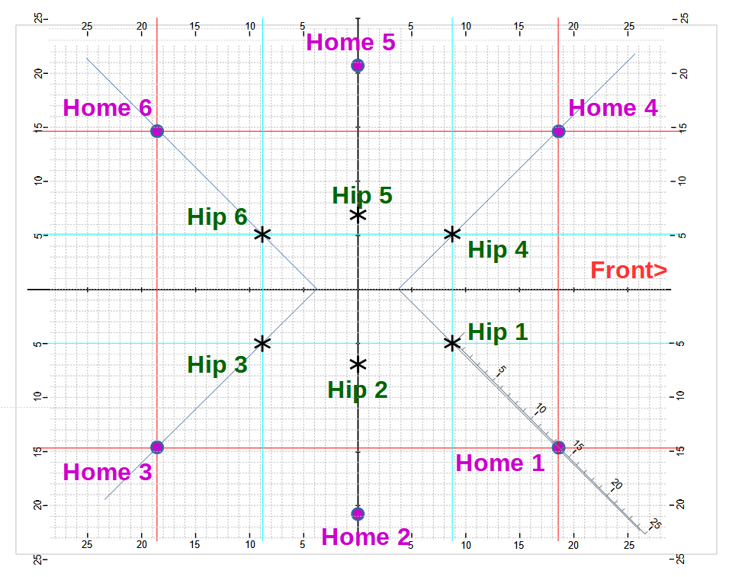

Move leg 1 to its home position
Using operation code 1, where the numbers are global coordinates:
FL,1000,1,10,0,0,0, 18.62, -14.79, -10.60, ...
Explanation: Direct use of the global coordinate system. (The easy way is to look this up in section 15.1.) The scales on the edges of the above diagram show global X and Y coordinates.
Using operation code 2, where the numbers are local coordinates:
FL,1000,1,10,0,0,0, 13.78, -10.60, 0, ...
Explanation: The local origin is above the leg’s hip servo, at the same height as the center of the knee servo. The X value is the sum of the lengths of the thigh ( 2.92) plus the shin (7.72) plus the toe offset(3.23) = 13.78. The Y value is the length of the foot, and it’s negative because it’s below the origin, -10.60. Since the home position occurs when the hip servo is at its center, the Z coordinate is 0. (Or, you could look it up in section 15.2 .) Here’s an illustration showing the local coordinate axes in blue:

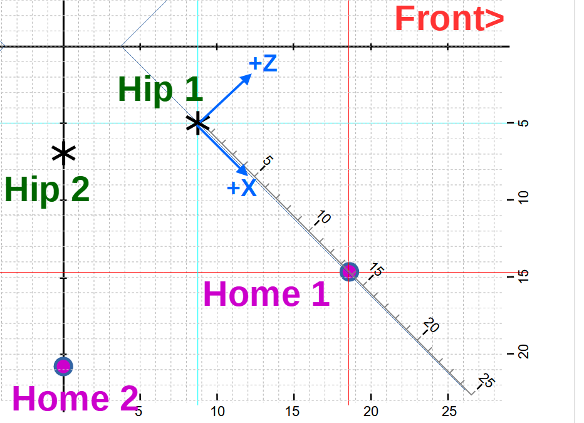

Using operation code 3, where numbers are global coordinate deltas relative to home pos’n
FL,1000,1,10,0,0,0, 0, 0, 0, ...
Explanation: This operation code uses numbers relative to the home position, i.e. the numbers are offsets from home in the global coordinate directions. Since we want the home position itself, the offsets are zero.
Using operation code 4, where numbers are local coordinate deltas relative to home pos’n
FL,1000,1,10,0,0,0, 0, 0, 0, ...
Explanation: This operation code also uses numbers relative to the home position, i.e. the numbers are offsets from home in the local coordinate directions. Since we want the home position itself, the offsets are zero.

Move leg 1 to a position 4 Cm in front of its home position
NOTE: “in front of” means towards the front of the robot, in the global +X direction. In this diagram of Leg 1’s corner, this target position is indicated by a red filled in circle.
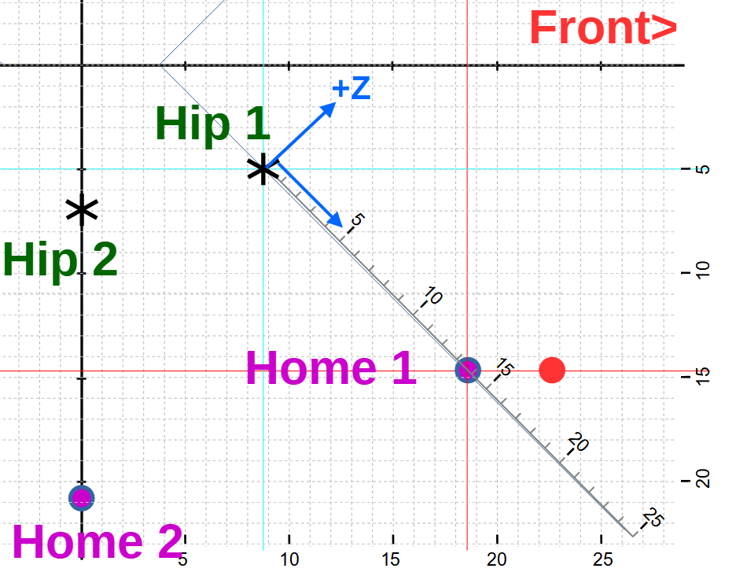

Using operation code 1, where the numbers are global coordinates:
FL,1000,1,10,0,0,0, 22.62, -14.79, -10.60, ...
Explanation: Direct use of the global coordinate system plus an offset in the global X direction. We take the known global coordinates for the home position, and add 4 to the X coordinate.

Using operation code 2, where the numbers are local coordinates:
FL,1000,1,10,0,0,0, 16.61, -10.60, 2.83, ...
Explanation: The offset isn’t aligned with the local coordinates, so we’ll end up changing both the local X and Z coordinates of the home position. Here’s an illustration of how we break the offset down to a combination of local X and Z changes:
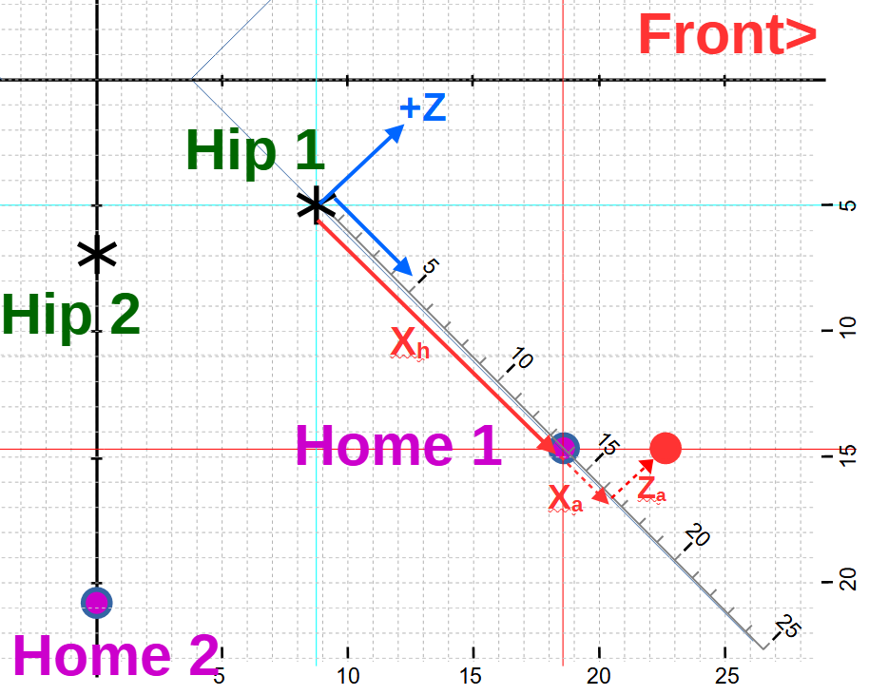

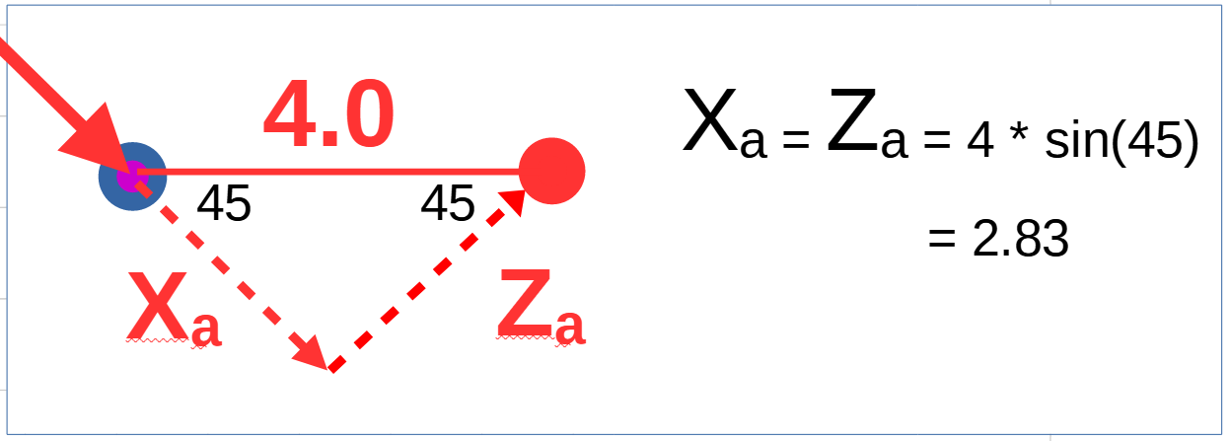
Zeroing in on the adjustments we need to make from the home position to get to the target...
Xa is what we need to add to the home position’s X coordinate, and Za is what we need to add to it’s Z component. Thus, the new coordinates are:
X = 13.78 + 2.83 = 16.61
Z = 0 + 2.83 = 2.83
Using operation code 3, where numbers are global coordinate deltas relative to home pos’n
FL,1000,1,10,0,0,0, 4, 0, 0, ...
Explanation: This one is easy, because it’s based on the home position, and it uses global coordinate offsets, same as the way our target location is defined. We have a 4.0 cm offset in the global +X direction, and no other offsets.

Using operation code 4, where numbers are local coordinate deltas relative to home pos’n
FL,1000,1,10,0,0,0, 2.83, 0, 2.83, ...
Explanation: As with operation code 2, we need to adjustments to the local coordinates needed to achieve the target offset of 4 cm in the global X direction. All the same calculations apply, but in the flow command, we just include the adjustments relative to the home position, rather than recalculated local coordinates.

Example Flow Script -Taking A Step
A frequent Hexbot operation is taking a step that moves the robot a small amount relative to the floor. We’re going to build on our previous examples to create a script that moves the Hexbot forward by 4 cm. However, because we work in the perspective of the robot, it’s much easier to think that we’re pushing the floor backwards.
The entries that need to be included in every script are described in section 7 Putting Flow Commands into a Script . We’ll assume you will follow that, and we’ll concentrate on the flow commands that achieve the step.
While taking a step, one group of legs must be on the floor, perhaps moving, while the other set of legs is above the floor, repositioning for its turn on the floor. These groups need to be able to support the robot on their own. Using the sets (1,2,3) and (4,5,6) wouldn’t work, because all the legs on one side would be raised at the same time and the robot would be unstable. A better grouping is to use the odd numbered legs for one group, and the evens for the other: (1,3,5) and (2,4,6) . Each of these groups forms a large triangle on the floor, which can support the robot in a stable way. From now on, I’ll refer to these groups as the odds and the evens.

The Sequence of Actions
A logical sequence of actions for this movement might be:
- start with all legs in the home position
- lift the odds off the floor
- move them 4 cm towards the front of the Hexbot
- lower the odds
- lift the evens
- pull the odds back to the home position, moving the robot 4 cm forward
- ...repeat to move another 4 cm ...
We’ve now met the goal of moving forward 4 cm, but not very efficiently. The robot is only moving relative to the floor in one of the 6 stages, and we haven’t used the evens at all.
This sequence takes 10 stages to move 8 cm.
We can make use of the fact that all six legs can move in every flow command to improve this sequence of stages:
- start with all legs in the home position
- lift the odd legs off the floor
- move the evens 4 cm backwards
- lower the odds
- raise the evens
- move the odds 4 cm backwards, and return evens to be over home positions
- lower the evens
- raise the odds
- move the evens 4 cm backwards, and return the odds to be over the home position
- .. repeat ...
This improved sequence takes 6 stages to move 8 cm, and movement is almost continuous. There are still improvements we could make to this sequence, but let’s get the basic flow script working first.
To decide which type of flow operation we want to use, we look at the nature of the motion. In this sequence, all of the motion (other than up and down) is movement of legs in the plus and minus global X direction. It’s also all focused on the home positions. So it seems like using operation 3, when the numbers for each leg are offsets from the home position using global coordinates would be efficient. Next we need to create flow commands for each stage in our improved sequence. We’ll start with one second durations for each flow, which makes it easier to observe and interpret the robot’s actions. We can optimize the timing later.

Converting Actions to Flow Commands
Stage 1: start with all legs in the home position
We can use either of the operation codes that are based on the home position, and give zero offsets, so we’re left with just the home position:
FL,1000,3,10,0,0,0, 0,0,0, 0,0,0, 0,0,0, 0,0,0, 0,0,0, 0,0,0

Stage 2: lift the odd legs off the floor
The 3rd global coordinate is Z which is up and down. Up is positive, so we can raise the legs (just the odds) by using an offset of 2 in the third coordinate of those legs.
FL, 1000, 3, 10,0,0,0, 0,0,2, 0,0,0, 0,0,2, 0,0,0, 0,0,2, 0,0,0

Stage 3: move the evens 4 cm backwards
This is where using operation code 3 pays off. We just put the offset of -4 cm into the X coordinate for the evens. We also have to keep the odds in the air, so we maintain what we did in the previous flow. This stage moves the robot forward.
FL, 1000, 3, 10,0,0,0, 0,0,2, -4,0,0, 0,0,2, -4,0,0, 0,0,2, -4,0,0

Stage 4: lower the odds
The 3rd global coordinate is Z which is up and down. We’re undoing what we did in stage 2, but maintaining the positions of the other legs
FL, 1000, 3, 10,0,0,0, 0,0,0, -4,0,0, 0,0,0, -4,0,0, 0,0,0, -4,0,0

Stage 5: raise the evens
Same old use of the 3rd coordinate, but for the even legs, conserving everything else
FL, 1000, 3, 10,0,0,0, 0,0,0, -4,0,2, 0,0,0, -4,0,2, 0,0,0, -4,0,2
Stage 6: move the odds 4 cm backwards, and return evens to be over home positions
The odds are going backwards, so their X offset is -4. The evens are coming back to the home position, still in the air, so their X offset is 0. This stage moves the robot forward.
FL, 1000, 3, 10,0,0,0, -4,0,0, 0,0,2, -4,0,0, 0,0,2, -4,0,0, 0,0,2

Stage 7: lower the evens
So we get rid of their +2 offset and put them back to the home position
FL, 1000, 3, 10,0,0,0, -4,0,0, 0,0,0, -4,0,0, 0,0,0, -4,0,0, 0,0,0

Stage 8: raise the odds
OK, so their Z offset, third coordinate will be 2
FL, 1000, 3, 10,0,0,0, -4,0,2, 0,0,0, -4,0,2, 0,0,0, -4,0,2, 0,0,0

Stage 9: move the evens 4 cm backwards, and return the odds to be over the home position
Like step 6, but the roles of the evens and odds are reversed. This stage moves the robot forward.
FL, 1000, 3, 10,0,0,0 0,0,2, -4,0,0, 0,0,2, -4,0,0, 0,0,2, -4,0,0

Consolidated Flow Listing
Here’s what we ended up with. See ../docs/MQTT scripts/onestep for an executable version.
- FL, 1000, 3, 10,0,0,0, 0,0,0, 0,0,0, 0,0,0, 0,0,0, 0,0,0, 0,0,0
- FL, 1000, 3, 10,0,0,0, 0,0,2, 0,0,0, 0,0,2, 0,0,0, 0,0,2, 0,0,0
- FL, 1000, 3, 10,0,0,0, 0,0,2, -4,0,0, 0,0,2, -4,0,0, 0,0,2, -4,0,0
- FL, 1000, 3, 10,0,0,0, 0,0,0, -4,0,0, 0,0,0, -4,0,0, 0,0,0, -4,0,0
- FL, 1000, 3, 10,0,0,0, 0,0,0, -4,0,2, 0,0,0, -4,0,2, 0,0,0, -4,0,2
- FL, 1000, 3, 10,0,0,0, -4,0,0, 0,0,2, -4,0,0, 0,0,2, -4,0,0, 0,0,2
- FL, 1000, 3, 10,0,0,0, -4,0,0, 0,0,0, -4,0,0, 0,0,0, -4,0,0, 0,0,0
- FL, 1000, 3, 10,0,0,0, -4,0,2, 0,0,0, -4,0,2, 0,0,0, -4,0,2, 0,0,0
- FL, 1000, 3, 10,0,0,0, 0,0,2, -4,0,0, 0,0,2, -4,0,0, 0,0,2, -4,0,0

